

**SECP1513-06 TECHNOLOGY AND INFORMATION SYSTEM**

________________________________________________________________________

**Design Thinking** 

SECTION:06-SECJH

COURSE NAME: BACHELOR OF COMPUTER SCIENCE – SOFTWARE ENGINEERING

LECTURER’S NAME: TS. DR. SARINA BINTI SULAIMAN

GROUP: 2- JELLYBEAN

DATE OF SUBMISSION: 27 JANUARY 2024

| NO. | NAME | MATRIC NUMBER |
| --- | --- | --- |
| 1 | LEW SHU BEI | A22EC8002 |
| 2 | TAN SHEAU JUN | A22EC8001 |
| 3 | SITI NUR FATHIYYAH BINTI MARZUKEE | A23CS0269 |
| 4 | AFLAKH RASIKH IBADURRAHMAN | A22EC4022 |
| 5 | HUMAIRA SHEYLA NURFAYZA | A23CS4010 |

### **Table of Contents**

| NO. | CONTENTS | PAGE |
| --- | --- | --- |
| 1 | Introduction | 3 |
| 2 | Detail Step and Descriptions | 4-5 |
| 3 | Detailed Description | 6-8 |
| 4 | Design Thinking Assessment | 9 |
| 5 | Design Thinking Evidence  a. The sample work by students working to solve the design challenge  b. Record for each phase  i. Empathy  ii. Define: List of define  iii. Ideate: Brainstorm process  iv. Prototype  v. Test: Test the prototype to the user | 10-15 |
| 6 | Reflection for Each Member | 16-19 |
| 7 | The Task for Each Member | 20 |

### **1.0 Introduction**

Design thinking is a method of innovation that enables students to create solutions for users by focusing on a specific problem statement. This skill is highly useful for solving difficult issues that are unfamiliar to students.It will allow students to understanding the objective of a specific topic in this course as we have to provide a solution or a new hardware by using our creative and also our group members should provides any new idea for developing a new devices since the our report is mainly focus on one of the topics which is hardware.

**Hardware**

Hardware refers to the external and internal devices and equipment that enable you to perform major functions such as input, output, storage, communication, processing, and more. The user had to face the problems regarding the hardware function that is input and output.

Input devices translate data into a form that the system unit can process including keyboards, mice, pointing, scanning, image capturing and audio-input. Output devices processed data or information such as text, graphics or photos, audio and video.

**2.0 Detail step and descriptions**

1. Empathy

Empathy is the stage when we observe the user’s view and their behavior in the context of their lives. In this stage, we need to listen and gather information about the problem faced by the user. We specifically target the younger generation because they are more experts in using the gadget nowadays. During the interview, we asked the user what problem they often faced when using the application on their gadget, particularly smartphones.

1. Define

Define is when we recognise the problem faced by the user. At this point, we need to have a deep understanding of the user’s problems before we come up with an actionable problem statement. We then establish a clear idea of exactly which problem we will solve based on what we have learned about the user.

1. Ideate

Ideate is the phase where we had the brainstorm session to solve the problem faced by the user. All the members gave their point of view on how to solve the problem. We identified all the possibilities that can solve the problem and tried to develop the solution so that the user will be satisfied with our product later on. We then came out with the best solution to solve the problem so that we can continue working on the prototype.

1. Prototype

For this prototype phase, we create a prototype based on the previously discussed idea. We design the software by developing an application that can ease the user’s daily life. This application can be used in the TikTok platform to play the next video by scanning their face. The advantage of this application is that the user only needs to head up or down to see the next or previous video. This is really helpful for the user as they just move their head instead of moving their fingers to scroll up the video. This prototype can help the user to solve the problem faced and the user will be delighted with the product.

1. Test

Test is the stage where we let the user test the prototype and get the feedback from the user to figure out whether our product is functioning to solve the problem or not. This stage is crucial so we can try to fix our prototype if there is a deficiency in our prototype. We briefly explain to the user the features of the application that we develop and demonstrate the user how to use it.

**3.0 Detailed Description**

**3.1 Problems**

1. **Portable Health Monitoring Devices**

The problem of limited access to real-time health data outside of hospitals is a significant issue in today's healthcare. Even though hospitals have advanced technology to track patient information, it's tough to share this data quickly outside of the hospital. This difficulty makes it challenging to keep a close eye on a person's health consistently and deal with any issues promptly. People often can't easily get updates on their health or share important information with their doctors. Additionally, there's a lack of a smooth way for hospitals, clinics, and other healthcare places to share information, making it hard to manage patient care in a connected way.

1. **Battery Degradation in Mobile Devices**

Smartphone batteries losing their quality over time is a big worry for users because it affects how well the device works. The batteries in smartphones naturally wear out as they get used, making them hold less charge. Things like charging too often, exposure to high temperatures, and lots of charging cycles speed up this wear and tear. When the battery can't hold as much charge, users notice that their phone needs to be charged more often. Also, weakened batteries may struggle to provide enough power during heavy use, causing issues like slower performance and unexpected shutdowns.

1. **Security Vulnerabilities in IoT Devices**

The surge in Internet of Things (IoT) devices has raised concerns about security because many of these devices lack strong security features. As the IoT network expands, various interconnected devices, from smart home gadgets to industrial sensors, often lack the necessary defenses against cyber threats. This deficiency makes them susceptible to potential cyberattacks, posing significant risks such as compromising user privacy, launching distributed denial-of-service (DDoS) attacks, or providing entry points for unauthorized access into larger networks. The complexity of IoT applications further complicates matters, as devices differ widely in functionality, and manufacturers may not uniformly prioritize security.

1. **Overheating in The System Unit**

System unit overheating is a big problem in computer hardware. The system unit, an important part of desktop computers, holds crucial components like the central processing unit (CPU) and memory modules. Overheating happens when these parts create too much heat during use, going beyond the system's ability to cool down. This prolonged heat can lead to issues like lower performance, system instability, and potential damage to the computer's parts. Common causes include poor ventilation, dust building up in cooling fans, or cooling systems not working well. It's important to regularly clean cooling fans and make sure there's good airflow to prevent overheating and keep computers running well.

**3.2 Solutions**

1. **Limited accessibility to real-time health data outside of hospitals**

A good solution to keep an eye on your health all the time is to make a small, wearable device. This device would check important things like your heart rate, blood pressure, and body temperature in an easy and portable way. With smart technology and sensors, it would fit into your daily life, making it simple to keep track of your health in real-time. The device could send the collected information to a special app or platform wirelessly, giving you current details about your health. This continuous monitoring helps you take charge of your well-being and catch possible health issues early. This handy and easy-to-use health monitor not only helps you stay aware of your health but also encourages a proactive and preventive approach to staying healthy.

1. **Battery Degradation in Mobile Devices**

To solve the problem of batteries not lasting long and wearing out, we can look into using different types of batteries, like solid-state batteries. Unlike the regular batteries, these ones use solid materials instead of liquids. They have some cool advantages like holding more energy, lasting longer, and being safer. If we invest in and improve this solid-state battery technology, it could make our electronic devices work better for longer without losing their power, and it would also be safer to use. Even though this kind of battery is still being worked on, it has the potential to change how we store energy for our devices, making them more reliable and sustainable in the long run.

1. **Security Vulnerabilities in IoT Devices**

To make Internet of Things (IoT) devices more secure, we can use strong security measures like hardware-based authentication and encryption. This means adding secure hardware components, like Trusted Platform Modules (TPMs), to the devices. These components help create secure connections between devices, protect sensitive information, and reduce the chances of unauthorized access or cyber threats. With hardware-based authentication, only the right users or devices can get into the IoT network, keeping out unauthorized ones. Also, by using encryption at the hardware level, data becomes scrambled and unreadable without the correct key. This extra security makes sure IoT devices are better protected, creating a safer environment for all kinds of applications in the IoT world.

1. **Overheating in The System Unit**

To fix the common problem of a system unit getting too hot, you can do a few things. First, clean the inside regularly to get rid of dust that might block airflow. Make sure the cooling fan is working well because if it's not, the system won't cool properly. Also, put the system unit in a place with good airflow and space around it. This helps the heat go away better. If you're not comfortable doing these tasks, it's a good idea to ask a professional for help to make sure everything is taken care of properly and the system doesn't get damaged.

**4.0 Design Thinking Assessment**

**4a During the end of the project demonstration**

It is very exciting to solve the user’s problems by successfully designing software. We had to discuss among ourselves to understand the user’s requirements. Thus, we can understand and stand by the user’s view when designing the project. This design is very useful to the younger generation today because they cannot live without gadgets. Through this project, I believe that this design is very convenient for them, especially when they are busy doing housework or homework.

**4b During the transition between design thinking phase**

During the early design thinking phase, we lack the idea about the way to represent our prototype due to the limited time we have .We have decided to use UI tools which is Figma to complete the prototype for the topic Hardware.However, we also faced some challenges, such as learning how to use the tool and designing the interface of the prototype. This was our first time using a UI tool, so it took us longer than expected.Nevertheless, we worked together as a team and completed the task successfully.

**5.0 Design Thinking Evidence**

**5a The sample work by students working to solve the design challenge**

i. Ideate: Brainstorm process

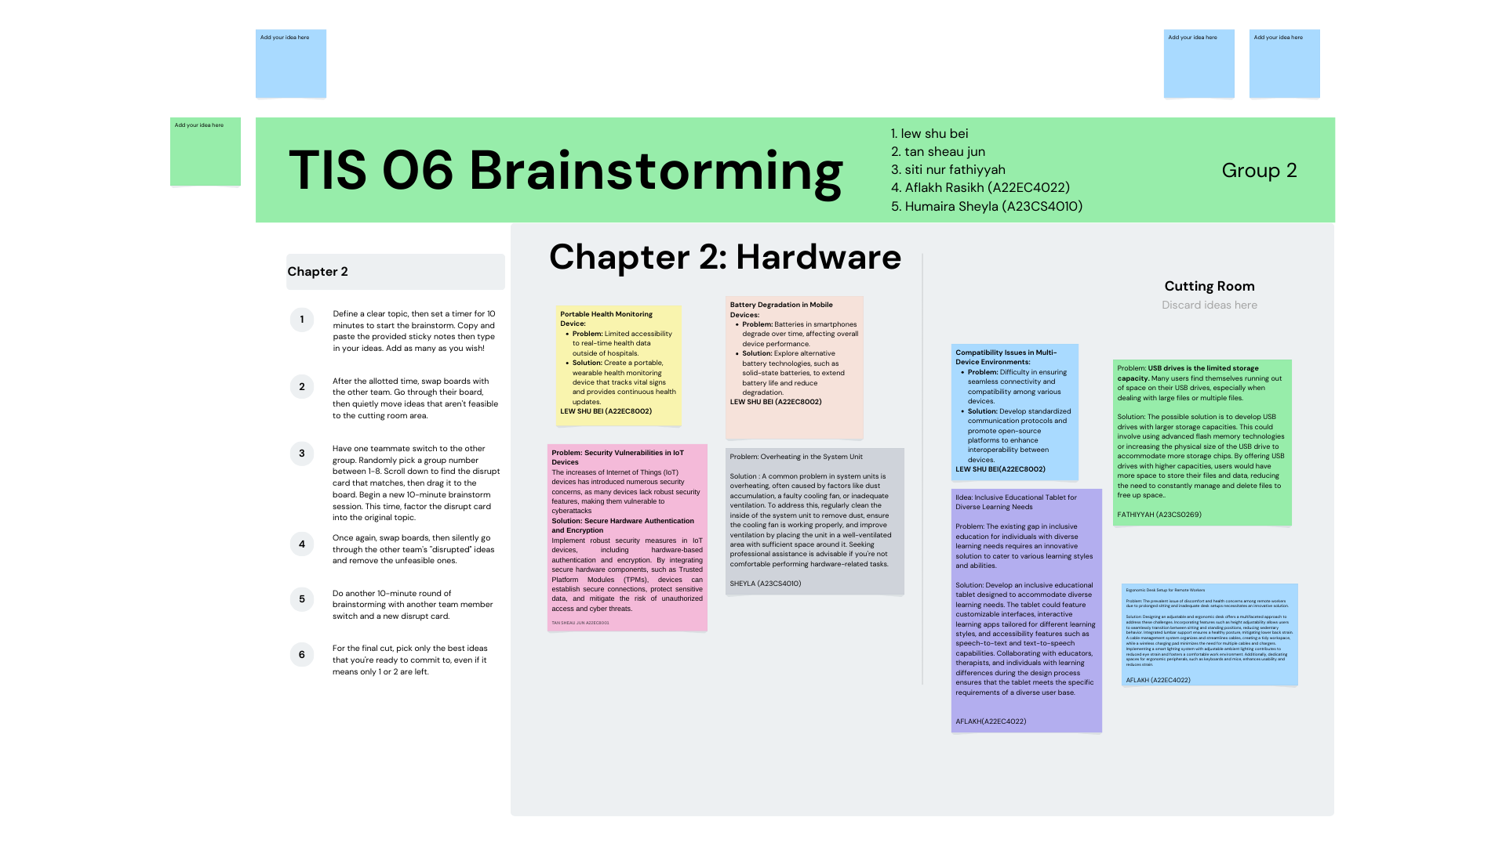

*Figure 5.2: Discussion for Define and Ideate stages*

ii. Prototype

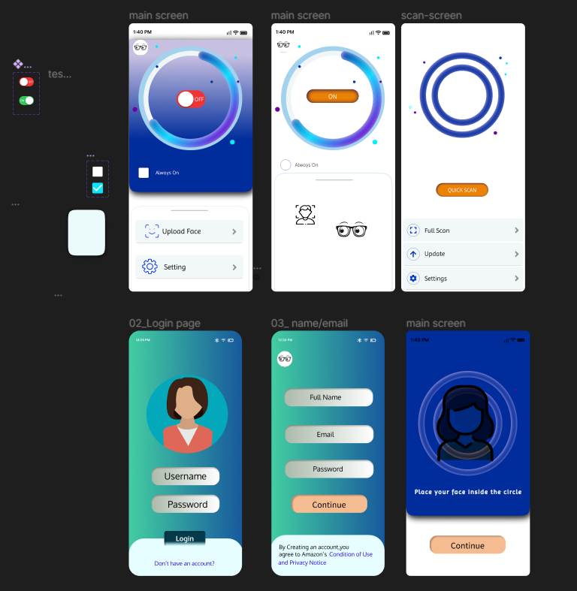

*Figure 5.3: Prototype stage*

iii. Test: Test the prototype to the user

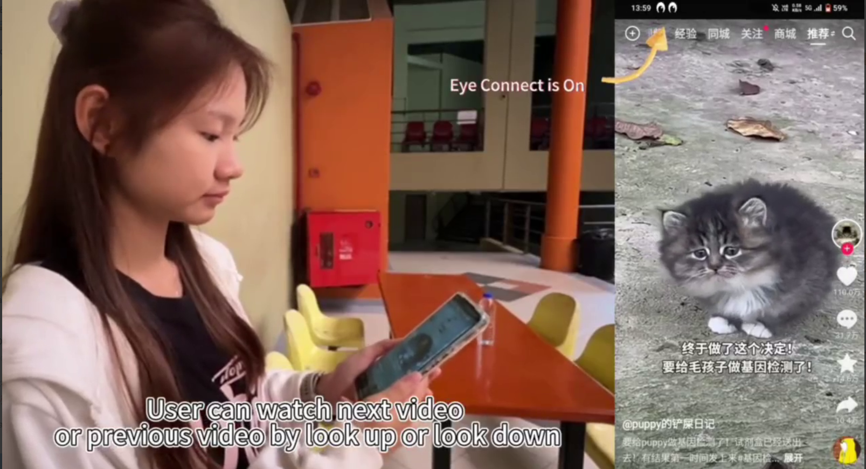

*Figure 5.3: Testing stage*

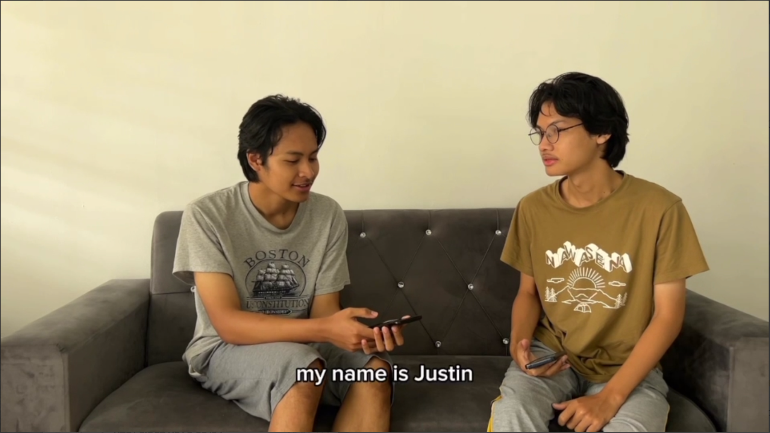

*Figure 5.4: Interview with user*

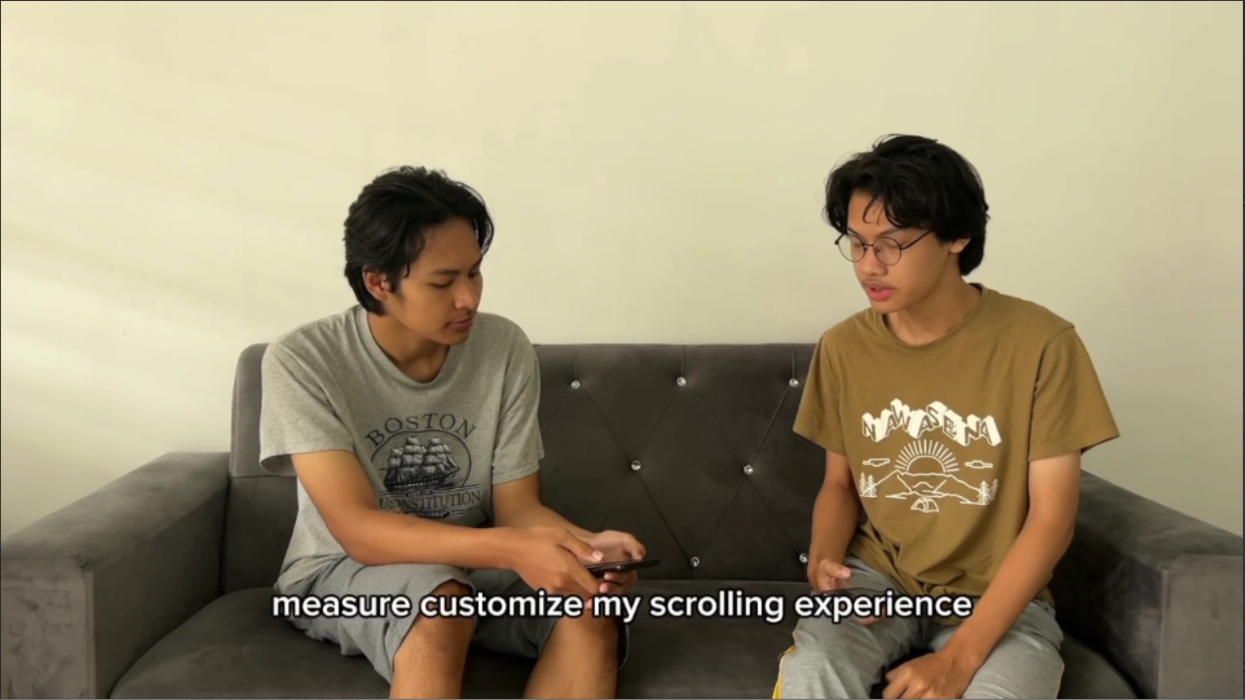

*Figure 5.5: Interview with user*

**5b. Record for each phase**

i. Empathy  
The table below shows the questions and answers that were obtained from the interview.

| **Questions** | **Answer** |
| --- | --- |
| What’s your name? | My name is justin |
| Are you a student? | Yes i am |
| How old are you? | 20 year old |
| How do you currently interact with social media platforms, particularly TikTok? | I usually use TikTok to watch short videos and explore various content. |
| Have you faced any specific situations or challenges while scrolling through content on TikTok? | Sometimes, the constant scrolling can be a bit cumbersome. |
| What makes using facial gestures for scrolling more interesting or efficient for you compared to conventional methods? | I believe using facial gestures for scrolling would be more convenient and engaging. |
| Are there any specific features you would like to see included in this prototype to enhance the user experience? | It would be great if the prototype could allow me to customize my scrolling experience. |
| Can you share your personal experience using facial gestures to interact with technology, if any? | I haven't used facial gestures extensively before |
| Are you comfortable using facial gestures for everyday interactions? | I'm open to trying new ways of interacting with technology. |

ii. Define: List of define

The problems faced by the respondent.

| **Problem** | **Description** |
| --- | --- |
| * Facing a problem for scrolling TikTok video using fingers | * Scrolling TikTok video using fingers sometime can be a bit cumbersome |

iii. Video for each stage

Video Link: <https://youtu.be/bsuIwS8br9Q>

**6.0 Reflection for each Team Members**

1. Lew Shu Bei
2. **What is your goal/dream with regard to your course/program?**

From this course, my goal is to have a deep understanding about technology and information system.From this course, i had gained a lot of valuable knowledge and practical skills.My dream is to use the knowledged i had learned in my career where i can engage in problem solving and give a positively impacts to the technology as well as society.

1. **How does this design thinking impact on your goal/dream with regard to your program?**

This design thinking assignment has an intense impact that relates to my goal for this course.I can learn how to help users to solve their problem with my creativity.This assignment also improves my ability to empathize with the users,so that i can develop a more user friendly hardware for the user.

1. **What is the action/improvement/plan necessary for you to improve your potential in the industry?**

To improve my potential for industry success I will continuously learn and update my skills including hard skill and soft skills.I will stay up to date on the latest tools and technologies through online courses or industry visits.

1. Tan Sheau Jun
2. **What is your goal/dream with regard to your course/program?**

My goal is to fully understand the lesson in this course, and I can apply this knowledge until I am working. This knowledge will not only help me to understand all the problems or questions, but it will also help me to solve the problems by considering the user's view in the first place.

1. **How does this design thinking impact on your goal/dream with regard to your program?**

This design thinking increases my creativity and problem solving. This is because this project needs creativity to design a system that fulfills the requirements of the user. I had to think of solutions, not existing software, in order to design the project.

1. **What is the action/improvement/plan necessary for you to improve your potential in the industry?**

I will put more effort into learning or enhancing the skills. Moreover, I will use all my knowledge and skills to give an industry talk to my future junior if I have the opportunity. This can not only let students gain knowledge in the field of ICT, but it can also let me solidify my skills forever and ever.

3. Siti Nur Fathiyyah binti Marzukee

1. **What is your goal/dream with regard to your course/program?**

My goal in this course is to acquire more knowledge and have a better understanding about the information technology field. This is because my dream job is related to this field, thus being an expert in this field will greatly benefit me in my future job.

1. **How does this design thinking impact on your goal/dream with regard to your program?**

The design thinking project has taught me the importance of gaining our soft skills in solving problems. Skills such as creative and critical thinking are useful in order to solve the problem faced by the user. The method ‘thinking out of box’ also needs to be applied by me as a thinker so that I can think in a creative way. I can say that this project impacted me a lot since I learned so many new things to be implemented in my daily life and in the future.

1. **What is the action/improvement/plan necessary for you to improve your potential in the industry?**

The plan that is necessary for me to improve my potential in the industry is expanding my knowledge base. I will employ a technique like always asking for help if there is something that I don’t understand. I also need to learn from mistakes that I make so that I will have a better understanding in the process of learning something. This really helps me in terms of adapting to the industry in the future.

4. Aflakh Rasikh Ibadurrahman

1. **What is your goal/dream with regard to your course/program?**

My primary goal in this course is to deepen my knowledge and gain a comprehensive understanding of the information technology field. This is crucial for pursuing my dream job, which is closely tied to this domain. By becoming an expert in this field, I aim to position myself for success in my future career.

1. **How does this design thinking impact on your goal/dream with regard to your program?**

The design thinking project has been instrumental in shaping my approach to problem-solving. It has emphasized the importance of soft skills, particularly creative and critical thinking, which are invaluable in addressing user needs effectively. The project introduced me to the concept of "thinking outside the box," fostering a more creative mindset. This newfound perspective is not only applicable to the project at hand but has also become a valuable tool that I can leverage in my daily life and future endeavors in the information technology field.

1. **What is the action/improvement/plan necessary for you to improve your potential in the industry?**

To enhance my potential in the industry, I have devised a plan focused on expanding my knowledge base and refining my skills. I recognize the importance of continuous learning and have committed to seeking help whenever needed. Actively engaging in the learning process and being open to assistance will contribute significantly to my growth. Additionally, I plan to embrace mistakes as learning opportunities, understanding that they are crucial for gaining a better understanding of the subject matter. This adaptive approach will be instrumental in preparing me for the challenges of the industry and ensuring a strong foundation for future success.

5. Humaira Sheyla Nurfayza

1. **What is your goal/dream with regard to your course/program?**

My dream in pursuing this course is to attain the job I aspire to, which is why I am dedicating myself to learning and deepening my understanding through this course. In addition to that, I also aim to acquire valuable skills and explore new experiences that will propel me forward. This journey is not only about achieving career goals but also about personal growth, as I strive to develop a strong skill set and embrace novel experiences that will contribute to my overall advancement.

1. **How does this design thinking impact on your goal/dream with regard to your program?**

This program has made me realize that everything we create or build may not last forever or have a lasting impact. One of the challenges in this program is addressing various issues, prompting us to seek solutions through the launch of new innovations that can simplify and minimize potential future problems. This highlights the importance of paying attention not only to recognizing potential issues but also to sharpening my problem-solving skills and gaining new experiences as I pursue my dreams. It emphasizes that pursuing my dreams involves not just identifying possible challenges but also honing my ability to solve problems and gaining new insights along the way.

1. **What is the action/improvement/plan necessary for you to improve your potential in the industry?**

I want to improve my skills in the industry by consistently learning and developing. This means keeping up with the latest industry trends, getting certifications, and joining relevant workshops or training programs. Building connections with professionals in the field and looking for mentorship opportunities will also give me valuable advice. Additionally, I aim to get practical experience through internships or projects. Overall, I am committed to staying adaptable and being open to learning new technologies and methods.

**7.0 Task for Each Members**

| NO. | TASK | TEAM MEMBERS |
| --- | --- | --- |
| 1 | Introduction | LEW SHU BEI  TAN SHEAU JUN |
| 2 | Detail Step and Descriptions | SITI NUR FATHIYYAH BINTI MARZUKEE |
| 3 | Detailed Description | HUMAIRA SHEYLA NURFAYZAAFLAKH RASIKH IBADURRAHMAN |
| 4 | Design Thinking Assessment | LEW SHU BEI  TAN SHEAU JUN |
| 5 | Design Thinking Evidence  a. The sample work by students working to solve the design challenge  b. Record for each phase  i. Empathy  ii. Define: List of define | HUMAIRA SHEYLA NURFAYZAAFLAKH RASIKH IBADURRAHMANSITI NUR FATHIYYAH BINTI MARZUKEE |
| iii. Ideate: Brainstorm process  iv. Prototype  v. Test: Test the prototype to the user | LEW SHU BEI  TAN SHEAU JUN |
| 6 | Reflection for Each Member | ALL MEMBERS |
| 7 | The Task for Each Member | LEW SHU BEI |